Department of education and science of Ukraine

National technical university of Ukraine

«Kyiv polytechnic institute the name of Igor Sikorsky»

Faculty of informatics and computing engineering

Department of the computing engineering

Laboratory work №1

Discipline: «The algorithms theory»

Topic: «The algorithms development. Sort by inclusion »

EXECUTED:

The first-year student

of FICT group IP-95

*Guskov Danil*

The Student book number- 9505

CHECKED:

Associate Professor

The Computer Engineering Department

PhD, SR

Antoniuk A.I.

Kyiv - 2020

**TASK**

**Goal:**

The creation of the algorithm for sorting by inclusion (insertion sort) .

**Task variant: 5**

Modify the insertion sort algorithm for the next task.

Incoming data. An array of integers: A = [30, 19, 9, 15, 55, 24, 3, 78, 46, 41].

Output data. Array of numbers A sorted this way: first, all the even numbers are in ascending order, and then all the odd numbers are in descending order.

**SOFTWARE CODE**

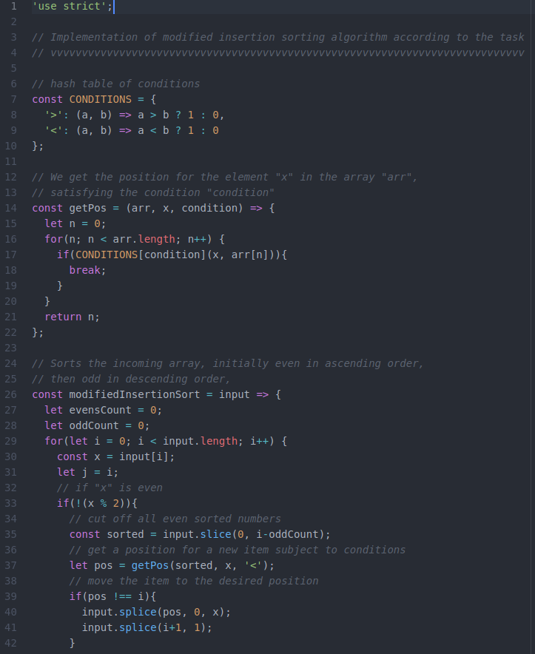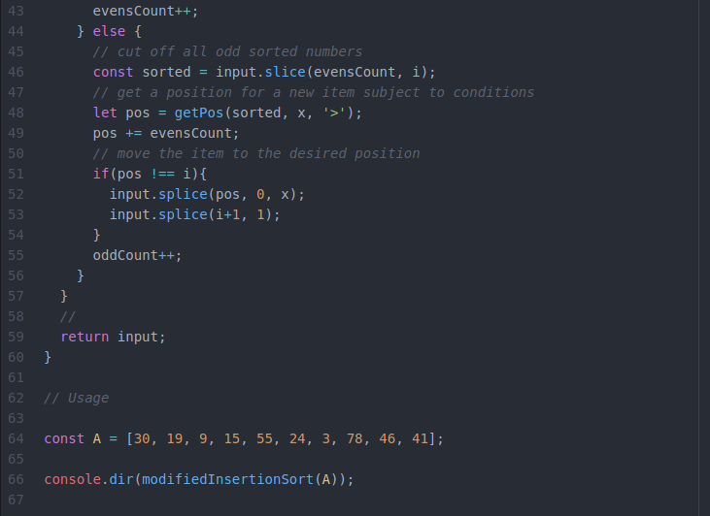

**RESULTS OF THE PROGRAM WORK**

The input array: 

Output array: 

**CONCLUSIONS**

Familiarized with the topic of laboratory work.

Have acquired relevant work skills.

An appropriate test program has been developed.

The results of the successful work of the test program above confirm the correctness of the chosen decisions, the ultimate goal of the work has been achieved.